3.1 & 3.2 The Derivative Function Worksheet

- Suppose a particle’s position is given by the equation , where s is measured in meters and t is measured in seconds.
- Find the average velocity of the particle during its first 4 seconds of motion. State answer with units.

- Find the instantaneous velocity of the particle after 1 seconds. State answer with units.

Therefore, the instantaneous rate of change at is

- Find if .

- Find an equation that will tell you slope of any tangent line on the graph of .

This means that we are looking for the derivative.

- Use the information found in problem #3 to construct the equation of a line that is tangent to the function at the point where .

To construct the tangent line we need the point on f where the tangent line is being constructed.
Point:
Slope:

Tangent Line:
- Find if .

You will have to multiple out unless you can utilize the Binomial Theorem.

- Find the derivative of .

- Suppose that we know that is an even function that is differentiable at . we know that has the following values:
Find .

Since is even then . Since is differentiable at then is continuous at .
So, .
- The graph of the function is shown below.
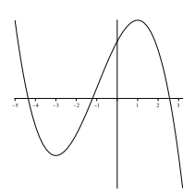

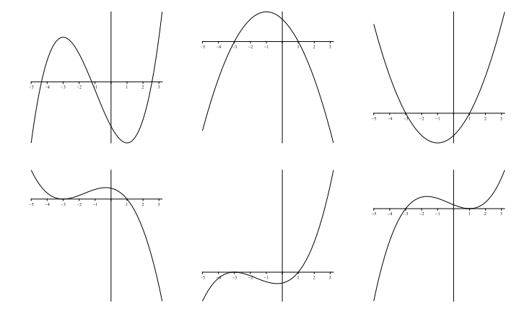
One of the six graphs below is the graph of . Circle the graph of .

